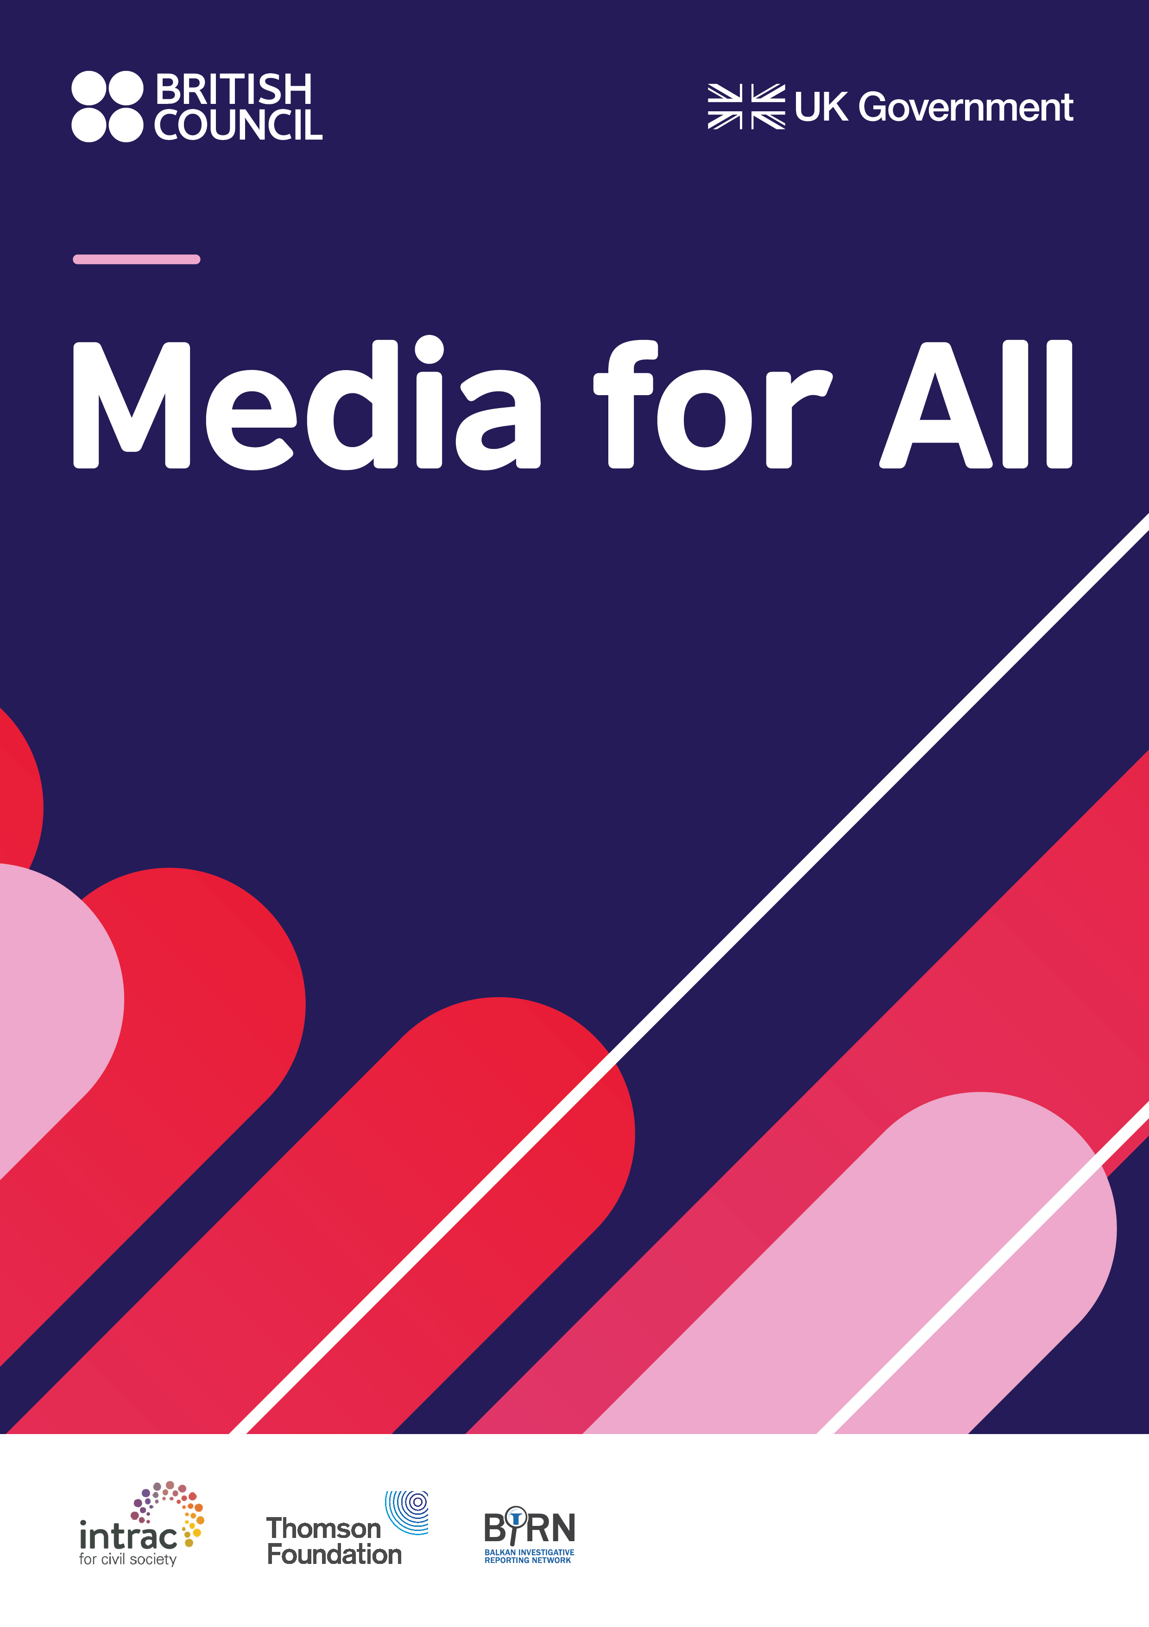

Young Journalists Competition

Background

The project ‘Media for All’ (the Project) is being delivered in Albania, Bosnia and Herzegovina, Kosovo, Montenegro, North Macedonia and Serbia. The aim of this media project is to strengthen the editorial independence of the media in the Western Balkans and support local independent media outlets to become more financially sustainable. The project is implemented by a consortium led by the British Council, with Balkans Investigative Reporting Network (BIRN), Thomson Foundation and INTRAC (The International NGO Training and Research Centre). The Media for All project started in September 2019 and runs until July 2022.

Youth activities

One aim of the Media for All programme is to increase the capacity of youth media outlets and young journalists in Albania, Bosnia and Herzegovina, Kosovo, Montenegro, North Macedonia and Serbia, to produce quality, relevant, ethical and gender-sensitive content, increase the interest and engagement of young people with media on local level and facilitate regional networks of young people in media.

Young Journalists Competition

The Media for All programme is opening entries for the **Young Journalists Competition**, a comprehensive programme offering a stipend scheme for journalists covering youth focused issues, mentorship and professional guidance, and promotion of the media content produced by the participating journalists in the media across the region.

The Competition is open for teams of journalists coming from different countries, working jointly on the production of youth focused media content with relevance for the young people across the WB region. 10 teams of three journalists will be selected to participate.

Each of the participating journalists will be awarded with a stipend amounting 500 GBP gross and the five best teams will be nominated to present their stories at the Media for All networking event and compete for valuable prizes.

Objectives of the Competition

Studies across the Western Balkans show regional trend of declining trust of youth in traditional media, with one of the reasons being that young people consider that traditional media do not offer relevant youth content nor give space to young people to produce their own news and shows[1]. Data also shows that youth are underrepresented in the media in WB in general, especially pronounced when it comes to providing comments as experts and news sources.[2] Youth in media is mostly being portrayed as homogeneous unit, often subjected to both, positive and negative stereotypes, reinforced by the social elite criticism for being passive and apathetic.[3]

Aiming to address some of the above challenges, Young Journalists Competition is specifically looking to:

* Encourage the production of high quality, relevant, ethical and gender-sensitive media content targeting young audience across the Western Balkans countries;
* Increase the interest and engagement of young people with media;
* Increase representation of youth in media production and increase the visibility of youth-focused issues in the Western Balkans;
* Increase relevance and visibility of common youth related challenges and their cross-border dimension at the Western Balkans;
* Contribute to balancing the stereotypical representation of youth in the Western Balkan's media;
* Encourage production of youth focused media content, by the young people.

Details of the Competition programme

The programme is scheduled to last eight weeks, from 16 September to 5 November, 2021. The five best teams will also participate at the networking event in the last week of November.

During this time, the selected teams will work on the production of the story based on the idea proposed in the application. Participation in weekly consultative sessions with the assigned mentor(s) is mandatory. All mentoring sessions will be held online, in English language.

Stories need to be produced in a minimum of two languages and prepared for publishing and social media promotion. All stories produced will be published in cooperation with media outlets across the WB. Publishing and promotion of the stories will be secured by the programme.

Any costs related to the production of the stories are to be covered by the awarded stipends (500 GBP gross for each participating team member).

Who can apply?

We welcome entries from teams of three journalists coming from a minimum of two different Western Balkans countries. Teams are expected to work jointly on the production of one story, with the support of the assigned mentor(s).

*The programme strongly encourages applications from fully assembled teams of three journalists from three different countries. Incomplete teams (less than three journalists or three journalists from two different countries), or individual applications will be considered in exceptional cases, where we will consider possible matching of participants to help form teams, based on the topics of the stories proposed within their applications. Advantage in selection will be given to fully formed teams of three.*

* All team members need to be in the 21-30 age range, and citizens of one of the six Western Balkans countries (Albania, Bosnia and Herzegovina, Kosovo, Montenegro, North Macedonia, Serbia).
* All team members should be able to demonstrate experience and active engagement in journalism.
* All team members need to have excellent command of English language and be able to follow the sessions with their mentor(s) in English.
* All team members need to demonstrate commitment to full participation in the production process and commitment to working with the mentor(s).

What content forms and topics can be covered?

Any format of the proposed media content is welcomed: text, audio, video, multimedia, podcasts, blogs, vlogs and other forms as proposed by the participants.

The Competition is open for proposals covering any of the following topics below. Feel free to propose a subject beyond those listed, as long as you can demonstrate the relevance and importance of the topic to the young people of the Western Balkans.

* youth employment,
* gender equality and gender issues,
* migrations,
* environment,
* consequences of the pandemic on young people,
* local politics and the youth,
* youth activism,
* youth violence,
* youth and the media.

Details of the award/stipend

Each of the members of the team who enter the programme will be awarded with a stipend of 500 GBP gross (amount inclusive of all relevant taxes). No additional funds will be provided for the production of stories.

Members of the five best teams will be invited to a face to face networking event (Covid-19 pandemic permitting), scheduled to take place in the last week of November, where they will have the opportunity to present their stories to a jury of renowned journalists and compete for production equipment awards (total value of 3.000,00 GBP).

Costs related to participation in the networking event (travel and accommodation) will be covered by the programme.

Assessment and selection of applications

All applications will be assessed by a selection committee based on the following criteria:

* Relevance of the proposed topic/idea against the objectives of the Competition and topics indicated as eligible;
* Quality of the proposed idea, approach to the proposed topic, originality of the proposal;
* Team composition – number of countries involved, experience of team members and quality of the previous works.

1. Sanela Hodžić i Anida Sokol. (2019). Surfanje po tankom ledu: Mladi, mediji i problematični medijskih sadržaji. Mediacentar Sarajevo. Available at: https://www.media.ba/sites/default/files/mladi_mediji_problematicni_medijski_sadrzaji_web.pdf
2. Katarina Klingova, Dominika Hajdu – From Online Battlefield to Loss of Trust, GLOBSEC Policy institute, 2018. Available at:

   https://www.globsec.org/publications/online-battlefield-loss-of-trust/
3. See, for example, media portrayal of youth in Serbia in Stefan Janjić – Mladi u medijskom ogledalu, Krovna organizacija mladih Srbije – KOMS, 2017. Available at:

   <https://koms.rs/wp-content/uploads/2017/12/Mladi-u-medijskom-ogledalu-.pdf>